Examen 1

1. Question
View and examine the structure of the ORDER_ITEMS table. Required: Select the ORDER_ID of the order that has the highest total value among all the orders in the ORDER_ITEMS table. Identify the response which would meet the requirement.
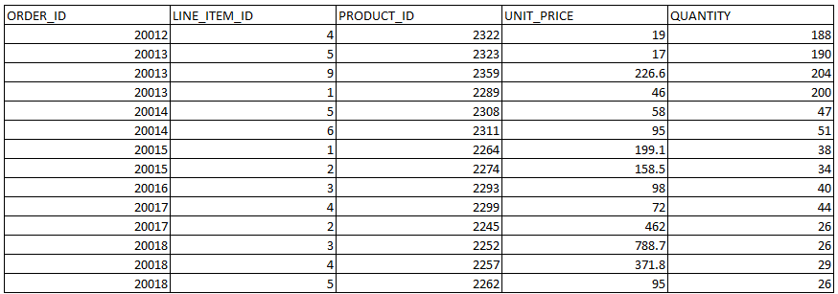
Required: Select the ORDER_ID of the order that has the highest total value among all the orders in the ORDER_ITEMS table.
Identity the response which would meet the requirement.
- SELECT order_id, MAX(unit_price*quantity) AS "LARGEST ORDER" FROM order_items WHERE(unit_price*quantity) = ( SELECT MAX(unit_price*quantity) FROM order_items) GROUP BY order_id;
- SELECT order_id, MAX(unit_price*quantity) AS "LARGEST ORDER" FROM order_items WHERE (unit_price*quantity) = ( SELECT MAX(unit_price*quantity) FROM order_items GROUP BY order_id);
- SELECT order_id, MAX(unit_price*quantity) AS "LARGEST ORDER" FROM order_items WHERE(unit_price*quantity) = MAX(unit_price*quantity) GROUP BY order_id;
- SELECT order_id, MAX(unit_price*quantity) AS "LARGEST ORDER" FROM order_items GROUP BY order_id HAVING SUM(unit_price*quantity) = ( SELECT MAX(SUM(unit_price*quantity)) FROM order_items GROUP BY order_id);

Correcta: D

2. Question
View and examine the following available responses.
Identity two statements which are true about the SET VERIFY ON command? (Select two)
A. It is both an SQL Developer and SQL*Plus native command
B. It can be used only in SQL*Plus.
C. It displays values for variables used only in the WHERE clause of a query.
D. It displays values for variables created by the DEFINE command.

Correcta:A,D
3. Question
View the exhibit and examine the data in the PROJ_TASK_DETAILS table.
Table: PROJ_TASK_DETAILS
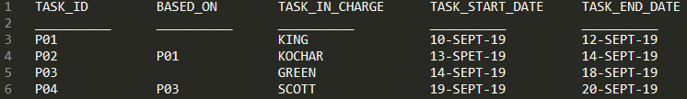
Given: The PROJ_TASK_DETAILS table stores information about project tasks and the relation between them.
The BASED_ON column indicates dependencies between tasks.
Some tasks do not depend on the completion of other tasks.
Required: Generate a report listing all task IDs, the task ID of any task upon which it depends and the name of the employee in charge of the task upon which it depends.
Identity the SQL query which would give you the required output.
- SELECT p.task_id, p.based_on, d.task_in_charge FROM proj_task_details p FULL OUTER JOIN proj_task_details d ON (p.based_on = d.task_id);
- SELECT p.task_id, p.based_on, d.task_in_charge FROM proj_task_details p LEFT OUTER JOIN proj_task_details d ON (p.based_on = d.task_id);
- SELECT p.task_id, p.based_on, d.task_in_charge FROM proj_task_details p JOIN proj_task_details d ON (p.based_on = d.task_id);
- SELECT p.task_id, p.based_on, d.task_in_charge FROM proj_task_details p JOIN proj_task_details d ON (p.task_id = d.task_id);
Correcta: B
4. Question
View and examine the following available responses.
Identity the true statement regarding the default behaviour of the ORDER BY clause.
- NULLS are not included in the sort operation.
- In a character sort, the values are case-sensitive.
- Only columns that are specified in the SELECT list can be used in the ORDER BY clause.
- Numeric values are displayed in descending order if they have decimal positions.
- Column aliases can be used in the ORDER BY clause.
Correctas: B,E

5. Question
View and examine the following available responses.
Identity two true statements about conditional INSERT ALL.
- It cannot have an ELSE clause.
- Each WHEN condition is tested for each row returned by the subquery.
- The total number of rows inserted is always equal to the number of rows returned by the subquery.
- A single WHEN condition can be used for multiple INTO clauses.
- Each row returned by the subquery can be inserted into only a single target table.
Correctas: B,D

6. Question
Identify the two minimal requirements for a self-join.
- The table used for the self-join must have two different alias names in the query.
- There must be a condition on which the self-join is performed.
- No other condition except the self-join may be specified.
- Outer joins must not be used in the query.
- Only equijoin conditions may be used in the query.
Correcta: A,B
7. Question
View and examine the following available responses.
Identify two statements which are true regarding the USING and ON clauses in table joins.
- A maximum of one pair of columns can be joined between the two tables using the ON clause.
- Both USING and ON can be used for equijoins and nonequijoins.
- The WHERE clause can be used to apply additional conditions in SELECT statements containing the ON or the USING clause.
- The ON clause can be used to join tables on columns that have different names but compatible data types.
Correctas: C,D
8. Question
View and examine the structure of the ORDERS table.
Table: ORDERS
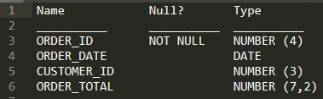
Given: The ORDERS table contains data and all orders have been assigned a customer ID.
Identity the statement which would add a NOT NULL constraint to the CUSTOMER_ID column.
- ALTER TABLE orders ADD customer_id NUMBER(6) CONSTRAINT orders_cust_id_nn NOT NULL;
- ALTER TABLE orders MODIFY customer_id NOT NULL;
- ALTER TABLE orders MODIFY CONSTRAINT orders_cust_id_nn NOT NULL (customer_id);
- ALTER TABLE orders ADD CONSTRAINT orders_cust_id_nn NOT NULL (customer_id);
Correcto: B
9. Question
View and examine the following scenario.
Given: The first DROP operation is performed on the PRODUCTS table using this command.
Exhibit: 1
Then a FLASHBACK operation is performed using this command.
Exhibit: 2
Identity the result of the FLASHBACK command.
- It recovers only the table structure.
- It recovers the table structure, data and the indexes.
- It is not possible to recover the table structure, data or the related indexes.
- It recovers the table structure and data but not the related indexes.
Correcta: C
10. Question
View the exhibit and examine the structure in ORDERS and ORDER_ITEMS tables. Required: Create a view that displays the ORDER_ID, ORDER_DATE, and the total number of items in each order indicated by appropriately named column. Identify the response which would meet the requirement.
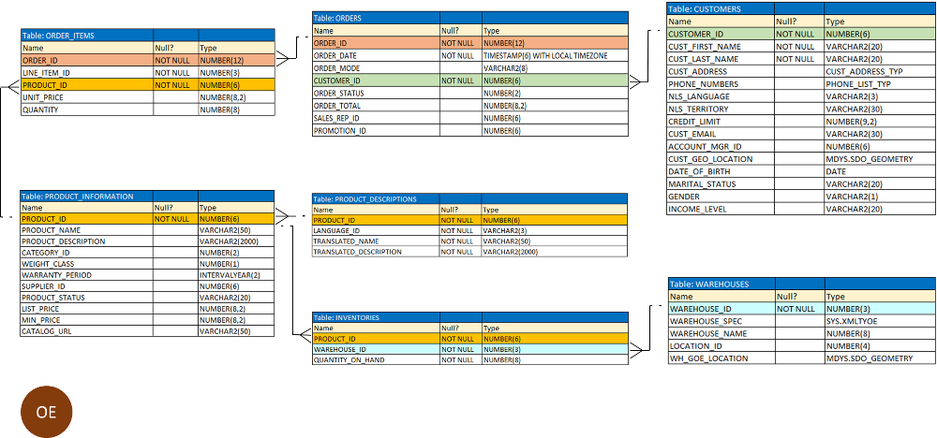
Required: Create a view that displays the ORDER_ID, ORDER_DATE, and the total number of items in each order indicated by appropriately named column.
Identity the response which would meet the requirement.
- CREATE OR REPLACE VIEW ord_vu (order_id, order_date) AS SELECT o.order_id, o.order_date, COUNT(i.line_item_id)"NO OF ITEMS" FROM orders o JOIN order_items i ON (o.order_id = i.order_id) GROUP BY o.order_id, o.order_date;
- CREATE OR REPLACE VIEW ord_vu AS SELECT o.order_id, o.order_date, COUNT(i.line_item_id) "NO OF ITEMS" FROM orders o JOIN order_items i ON (o.order_id = i.order_id) GROUP BY o.order_id,o.order_date;
- CREATE OR REPLACE VIEW ord_vu AS SELECT o.order_id, o.order_date, COUNT(i.line_item_id) FROM orders o JOIN order_items i ON (o.order_id = i.order_id) GROUP BY order_date;
- CREATE OR REPLACE VIEW ord_vu AS SELECT o.order_id, o.order_date, COUNT(i.line_item_id)||'NO OF ITEMS' FROM orders o JOIN order_items i ON (o.order_id = i.order_id) GROUP BY o.order_id,o.order_date WITH CHECK OPTION;
Correcta: B

11. Question
View and examine the structure of the BOOKS_TRANSACTIONS table and the exhibit.
Table: BOOKS_TRANSACTIONS
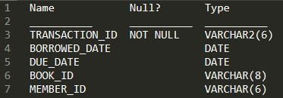
Examine this partial SQL statement.
Exhibit: 1
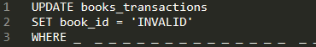
Required: Update this table such that BOOK_ID is set to ‘INVALID’ for all rows were no MEMBER_ID has been entered.
Identity the condition which must be used in the WHERE clause to perform the required update.
- member_id = "";
- member_id = '';
- member_id IS NULL;
- member_id = NULL;

Correcta: C

12. Question
View and examine the structure of the EMPLOYEES table and the exhibit.
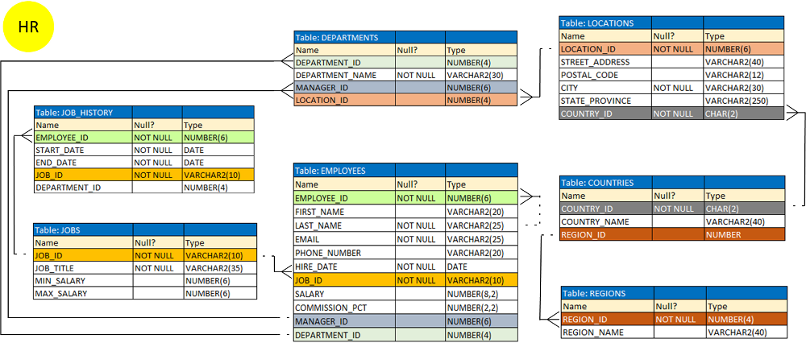
The following SQL query has been executed.
Exhibit: 1
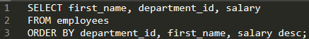
Indicate two statements which are true regarding the result. (Choose two.)
- The values in the SALARY column would be returned in descending order for all employees having the same value in the DEPARTMENT_ID and FIRST_NAME column.
- The values in the FIRST_NAME column would be returned in ascending order for all employees having the same value in the DEPARTMENT_ID column.
- The values in the FIRST_NAME column would be returned in descending order for all employees having the same value in the DEPARTMENT_ID column.
- The values in the SALARY column would be returned in descending order for all employees having the same value in the DEPARTMENT_ID column.
- The values in all columns would be returned in descending order.
Correctas: A,B
13. Question
View and examine the following available responses.
Identify three true statements regarding the SQL WHERE and HAVING clauses. (Choose three)
- The WHERE clause is used to exclude rows before grouping data.
- The HAVING clause conditions can use aliases for the columns.
- The HAVING clause conditions can have aggregating functions.
- The HAVING clause is used to exclude one or more aggregated results after grouping data.
- The WHERE and HAVING clauses cannot be used together in a SQL statement.
Correctas: A,C,D
14. Question
View and examine the structure of the SALES and PROMOTIONS tables.
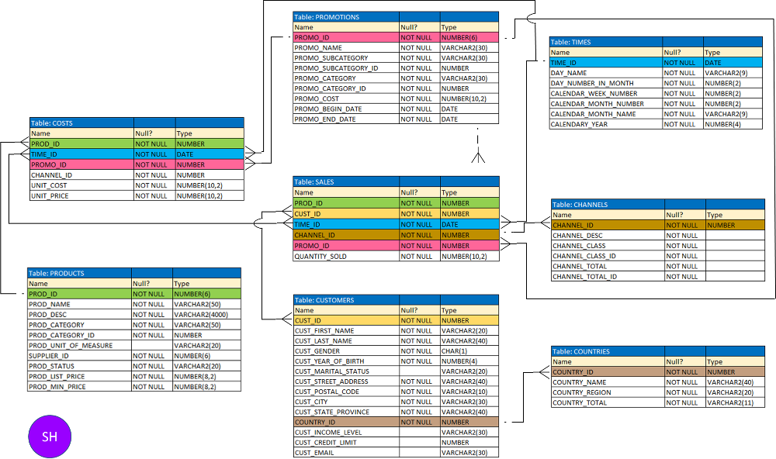
Required: Delete rows from the SALES table, where the PROMO_NAME column in the PROMOTIONS table has either blowout sale or everyday low price as values.
Identify three DELETE statements which are valid. (Choose three.)
- DELETE FROM sales WHERE promo_id IN ( SELECT promo_id FROM promotions WHERE promo_name IN = ('blowout sale','everyday low price'));
- DELETE FROM sales WHERE promo_id IN ( SELECT promo_id FROM promotions WHERE promo_name IN ('blowout sale','everyday low price'));
- DELETE FROM sales WHERE promo_id = ( SELECT promo_id FROM promotions WHERE promo_name = 'blowout sale') OR promo_id = ( SELECT promo_id FROM promotions WHERE promo_name = 'everyday low price');
- DELETE FROM sales WHERE promo_id IN ( SELECT promo_id FROM promotions WHERE promo_name = ('blowout sale' OR 'everyday low price'));
- DELETE FROM sales WHERE promo_id IN (( SELECT promo_id FROM promotions WHERE promo_name = 'blowout sale'),( SELECT promo_id FROM promotions WHERE promo_name = 'everyday low price'));
Correctas: B,C,E

15. Question
View and examine the following available responses.
The following query was successfully executed.
Exhibit: 1
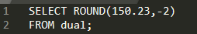
Identify the result of the query execution.
- 150.23
- 150.2
- 150.24
- 100
- 152
- 200
Correcta: F
16. Question
View and examine the structure of the PRODUCTS and NEW_PRODUCTS tables.
Table: PRODUCTS
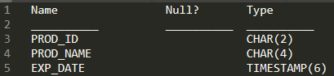
Table: NEW_PRODUCTS
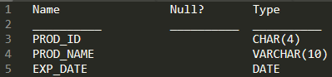
Identity two queries which execute successfully? (Choose two.)
- SELECT * FROM products MINUS SELECT prod_id FROM new_products;
- SELECT prod_id, exp_date FROM products UNION ALL SELECT prod_id, NULL FROM new_products;
- SELECT prod_id, prod_name FROM products INTERSECT SELECT 100, prod_name FROM new_products;
- SELECT * FROM products UNION SELECT * FROM new_products;
- SELECT prod_id FROM products UNION ALL SELECT prod_id, prod_name FROM new_products;
Correctas: B, D
17. Question
View and examine the following SQL query.
Exhibit: 1
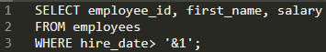
Required: Prevent prompting for a hire date value when this query is executed
Identity the responses which would meet the requirement. (Select two)
- Replace '&1' with '&&1' in the query.
- Execute the SET VERIFY ON command before executing the query.
- Store the query in a script and pass the substitution value to the script when executing it.
- Use the DEFINE command before executing the query.
- Execute the SET VERIFY OFF command before executing the query.
- Use the UNDEFINE command before executing the query.
Correctas: C,D
18. Question
View and examine the following available responses.
Indicate the true statement about the INTERSECT operator used in compound queries.
- It processes NULLs in the selected columns.
- It ignores NULLs.
- INTERSECT is of lower precedence than UNION or UNION ALL.
- Multiple INTERSECT operators are not possible in the same SQL statement.
Correcta: A
19. Question
View and examine the following SQL query which has been executed.
Exhibit: 1
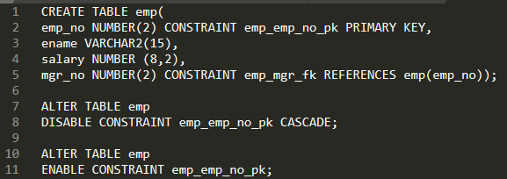
Indicate the status of the foreign key EMP_MGR_FK.
- It would be automatically enabled and immediate.
- It would remain disabled and can be enabled only by dropping the foreign key constraint and recreating it.
- It would be automatically enabled and deferred.
- It would remain disabled and has to be enabled manually using the ALTER TABLE command.
Correcta: D
20. Question
View and examine the following available responses.
Identify two true statements about transactions. (Select two)
- A transaction may consist of a set of DML or DCL statements.
- A part or an entire transaction can be made permanent with a COMMIT.
- A part or an entire transaction can be undone by using ROLLBACK command .
- A transaction can consist only of a set of DML and DDL statements.
- A transaction can consist of only a set of queries or DML or DDL statements.
Correctas: B,C
21. Question
View and examine the structure of the PROMOTIONS table.
Table: PROMOTIONS
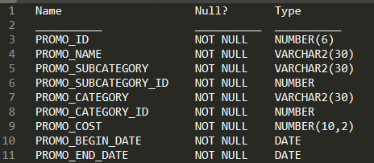
Required: Generate a report that displays the promo name and start date for all promos that started after the last promo in the ‘INTERNET’ category.
Identity the SQL query which would give you the required output.
- SELECT promo_name, promo_begin_date FROM promotions WHERE promo_begin_date > ALL ( SELECT MAX (promo_begin_date) FROM promotions) AND promo_category= 'INTERNET';
- SELECT promo_name, promo_begin_date FROM promotions WHERE promo_begin_date> ANY ( SELECT promo_begin_date FROM promotions WHERE promo_category= 'INTERNET');
- SELECT promo_name, promo_begin_date FROM promotions WHERE promo_begin_date > ALL ( SELECT promo_begin_date FROM promotions WHERE promo_category = 'INTERNET');
- SELECT promo_name, promo_begin_date FROM promotions WHERE promo_begin_date IN ( SELECT promo_begin_date FROM promotions WHERE promo_category= 'INTERNET');
Correcta: C
22. Question
View and examine the following available responses.
Identify two true statements about working with dates. (Select two)
- The default internal storage of dates is in the numeric format.
- The default internal storage of dates is in the character format.
- The RR date format automatically calculates the century from the SYSDATE function and does not allow the user to enter the century.
- The RR date format is interchangeable with the YY element
- The RRRR date format automatically calculates the century from the SYSDATE function but allows the user to enter the century if required.
Correctas: A,E
23. Question
View and examine the following available responses.
Indicate the true statement about aggregate functions.
- Aggregate functions can be used in any clause of a SELECT statement.
- Aggregate functions can be nested to any number of levels.
- The MAX and MIN functions can be used on columns with character data types.
- The AVG function implicitly converts NULLS to zero.
Correcta: C
24. Question
View and examine the structure of the MEMBERS table and the SQL statement. Identify the result of the query. (Choose the best answer).
Table: MEMBERS
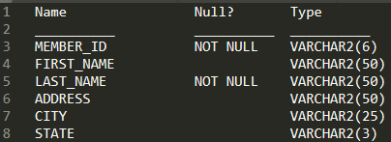
Examine the SQL statement.
Exhibit: 1
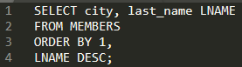
Identity the result of the query. (Choose the best answer)
- It displays all cities in ascending order, within which the last names are further sorted in descending order.
- It fails because a column number and a column alias cannot be used together in the ORDER BY clause.
- It displays all cities in descending order, within which the last names are further sorted in descending order.
- It fails because a column alias cannot be used in the ORDER BY clause.
Correcta: A
25. Question
View and examine the structure of ORDERS and CUSTOMERS tables.
Table: ORDERS
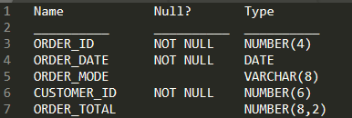
Table: CUSTOMERS
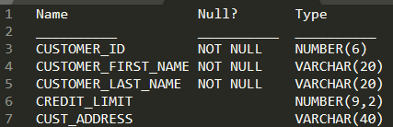
Given: Assume there exists only one row with CUST_LAST_NAME as Roberts and CREDIT_LIMIT as 600.
Required: Add a row into the ORDERS table for the customer whose CUST_LAST_NAME is Roberts and CREDIT_LIMIT is 600.
Identity the SQL query which would give you the required output.
- INSERT INTO( SELECT o.order_id, o.order_date, o.order_mode, c.customer_id, o.order_total FROM orders o, customers c WHERE o.customer_id = c.customer_id AND c.cust_last_name='Roberts' AND c.credit_limit=600) VALUES (1,'01/MAR/2020', 'direct', ( SELECT customer_id FROM customers WHERE customer_last_name='Roberts' AND credit_limit=600), 1000);
- INSERT INTO orders (order_id, order_date, order_mode,( SELECT customer_id FROM customers WHERE customer_last_name='Roberts' AND credit_limit=600), order_total) VALUES (1,'01/MAR/2020', 'direct', &&customer_id, 1000);
- INSERT INTO orders ( order_id, order_date, order_mode,( SELECT customer_id FROM customers WHERE customer_last_name='Roberts' AND credit_limit=600), order_total) VALUES (1,'01/MAR/2020', 'direct', &customer_id, 1000);
- INSERT INTO orders VALUES (1,'01/MAR/2020', 'direct',( SELECT customer_id FROM customers WHERE customer_last_name='Roberts' AND credit_limit=600),1000);
Correcta: D
26. Question
View and examine the following SQL exhibit and the available responses.
Required: Match the relationship examples which follow.
Exhibit: 1
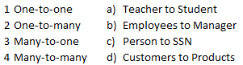
Identify the response which indicates correctly matched relationships.
- 1-c, 2-a, 3-b, and 4-d
- 1-a, 2-d, 3-c, and 4-b
- 1-a, 2-b, 3-c, and 4-d
- 1-d, 2-b, 3-a, and 4-c
Correcta: A
27. Question
View and examine the following SQL query.
Exhibit: 1
Identify two true statements about the result of the query.
- INSERT INTO rate_list VALUES (-10) produces an error.
- INSERT INTO rate_list VALUES (-99.99) inserts the value as 99.99.
- INSERT INTO rate_list VALUES (0.999) produces an error.
- INSERT INTO rate_list VALUES (0.551) inserts the value as .55.
- INSERT INTO rate_list VALUES (87654.556) inserts the value as 87654.6.
- INSERT INTO rate_list VALUES (-.9) inserts the value as -.9
Correctas: D,F
28. Question
View and examine the following available responses.
Identity two true statements about sequences created in a single instance Oracle database. (Choose two)
- When a database instance shuts down abnormally, sequence numbers that have been cached but not used are available again when the instance is restarted.
- CURRVAL is used to refer to the most recent sequence number that has been generated for a particular sequence.
- DELETEwould remove a sequence from the database.
- The numbers generated by an explicitly defined sequence can only be used to insert data in one table.
- When the MAXVALUE limit for a sequence is reached, it can be increased by using the ALTER SEQUENCE statement.
Correctas: B,E
29. Question
Identify two true statements regarding a SAVEPOINT. (Choose two)
- Rolling back to a SAVEPOINT can undo a CREATE INDEX statement
- A SAVEPOINT does not issue a COMMIT
- Rolling back to a SAVEPOINT can undo a TRUNCATE statement
- Only one SAVEPOINT may be issued in a transaction
- Rolling back to a SAVEPOINT can undo a DELETE statement
Correctas: B,E
30. Question
View and examine the following available responses.
Required: Display 5 percent of the rows from the SALES table for products with the lowest AMOUNT_SOLD and include the rows that have the same AMOUNT_SOLD even if this causes the output to exceed 5 percent of the rows.
Identity the response which would meet the requirement.
- SELECT prod_id, cust_id, amount_sold FROM sales ORDER BY amount_sold FETCH FIRST 5 PERCENT ROWS WITH TIES;
- SELECT prod_id, cust_id, amount_sold FROM sales ORDER BY amount_sold FETCH FIRST 5 PERCENT ROWS WITH TIES ONLY;
- SELECT prod_id, cust_id, amount_sold FROM sales ORDER BY amount_sold FETCH FIRST 5 PERCENT ROWS ONLY;
- SELECT prod_id, cust_id, amount_sold FROM sales ORDER BY amount_sold FETCH FIRST 5 PERCENT ROWS ONLY WITH TIES;
Correcta: A
31. Question
View and examine the following available responses.
Indicate two true statements regarding the UNION and UNION ALL operators. (Choose two)
- NULLS are not ignored during duplicate checking
- The number of columns selected in each SELECT statement must be identical
- The output is sorted by the UNION ALL operator
- Duplicates are eliminated automatically by the UNION ALL operator
- The names of columns selected in each SELECT statement must be identical
Correctas: A,B
32. Question
Identify two statements which are true regarding SAVEPOINTS. (Choose two)
- SAVEPOINTS can be used for both DML and DDL statements
- SAVEPOINTS are effective for both COMMIT and ROLLBACK.
- SAVEPOINTS are effective only for COMMIT.
- SAVEPOINTS can be used for only DML statements.
- SAVEPOINTS may be used to ROLLBACK.
Correctas: D,E
33. Question
View and examine the following SQL query.
Exhibit: 1
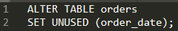
Identity the result of the query.
- The ORDER_DATE column must be empty for the ALTER TABLE command to execute successfully.
- ROLLBACK can be used to restore the ORDER_DATE column.
- The DESCRIBE command would still display the ORDER_DATE column.
- After executing the ALTER TABLE command, a new column called ORDER_DATE can be added to the ORDERS table.
Correcta: D
34. Question
View and examine the following available responses.
Identity three actions that can be performed using the ALTER TABLE command.
- Rename a table.
- Restrict all DML statements on a table.
- Drop several columns simultaneously from a table.
- Drop pseudocolumns from a table.
- Enable or disable constraints on a table.
- Lock a set of rows in a table.
Correctas: A,C,E
35. Question
View and examine the following available responses.
Identify the valid CREATE TABLE statement.
- CREATE TABLE ord_details ( ord_no NUMBER(2) UNIQUE, NOT NULL, item_no NUMBER(3), ord_date DATE DEFAULT SYSDATE NOT NULL);
- CREATE TABLE ord_details ( ord_no NUMBER(2) PRIMARY KEY, UNIQUE, NOT NULL, item_no NUMBER(3) PRIMARY KEY, ord_date DATE NOT NULL);
- CREATE TABLE ord_details ( ord_no NUMBER(2), item_no NUMBER(3), ord_date DATE DEFAULT SYSDATE NOT NULL, CONSTRAINT ord_pk PRIMARY KEY (ord_no, item_no));
- CREATE TABLE ord_details( ord_no NUMBER(2), item_no NUMBER(3), ord_date DATE DEFAULT NOT NULL, CONSTRAINT ord_uq UNIQUE (ord_no), CONSTRAINT ord_pk PRIMARY KEY (ord_no));
Correcta: C
36. Question
View and examine the following available responses.
Indicate two statements which best describe the benefits of using the WITH clause. (Choose two.)
- It enables sessions to store a query block permanently in memory and use it to create complex queries.
- It enables sessions to store the results of a query permanently.
- It enables sessions to reuse the same query block in a SELECT statement, if it occurs more than once in a complex query.
- It can improve the performance of a large query by storing the result of a query block having the WITH clause in the session's temporary tablespace.
Correctas: C,D
37. Question
View and examine the structure of the ORDERS table and exhibits.
Table: ORDERS
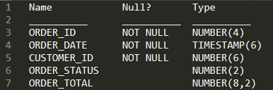
Required: Find the total value of all the orders for each year.
This command has been executed.
Exhibit: 1
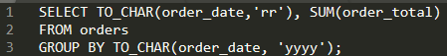
Identity the result of the query.
- It return an error because the datatype conversion in the SELECT list does not match the data type conversion in the GROUP BY clause.
- It executes successfully and gives the correct output.
- It returns an error because the TO_CHAR function is not valid.
- It executes successfully but does not give the correct output.
Correcta:A
38. Question
View and examine the structure of the BOOKS table and exhibits.
Exhibit: 1
Exhibit: 2
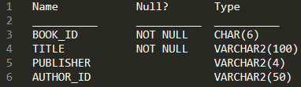
Given: The BOOKS table contains details of 100 books.
Examine the following commands executed and their outcomes.
Exhibit: 3
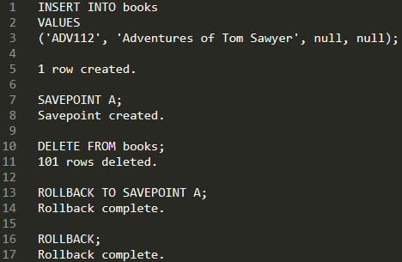
Indicate statement which is true regarding the result?
- Both ROLLBACK commands restore the 100 rows that were deleted.
- The first rollback restores the 100 rows that were deleted and the second rollback commits only the changes.
- Both ROLLBACK commands restore the 101 rows that were deleted.
- The first rollback restores the 101 rows that were deleted leaving the inserted row uncommitted.
Correcta: D
39. Question
View and examine the structure of the PRODUCTS and SALES tables as well as the exhibit.
Table: PRODUCTS
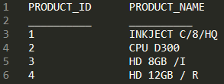
Table: SALES
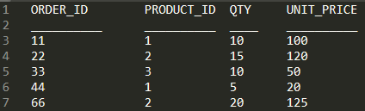
Required: Display PRODUCT_NAME and the number of times the product has been ordered.
The following SQL query has been executed.
Exhibit: 1
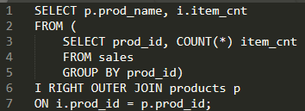
Identity the result of the query.
- The statement would not execute because the GROUP BY clause cannot be used in the inline.
- The statement would not execute because inline views and outer joins cannot be used together.
- The statement would execute successfully to produce the required output.
- The statement would not execute because the ITEM_CNT alias cannot be displayed in the outer query.
Correcta: C
40. Question
View and examine the following available responses.
Identify two true statements about single row functions.
- They can return a data type value different from the one that is referenced.
- They always return a single result row for every row of a queried table.
- Arguments can only be column values or constants.
- They can be nested only to two levels.
- They accept only a single argument.
Correctas: A,B
41. Question
View and examine the structure of the EMPLOYEES and JOB_HISTORY tables as well as the exhibits.
Required: Select the employee IDs of all the employees who have held the job SA_MAN at any time during their employment.
The following SQL queries have been prepared.
Exhibit: 1
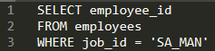
Exhibit: 2
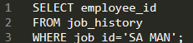
Indicate two correct SET operators which would cause the query to return the desired result. (Choose two.)
- UNION ALL
- MINUS
- INTERSECT
- UNION
Correctas: A,D

42. Question
View and examine the structure in the EMPLOYEES tables as well as the exhibit.
Evaluate the following SQL statement.
Exhibit: 1
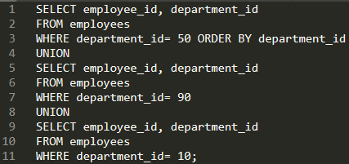
Identify the result of the query execution.
- The statement would not execute because the ORDER BY clause should appear only at the end of the SQL statement, that is, in the last SELECT statement.
- The statement would execute successfully and display all the rows in the ascending order of DEPARTMENT_ID.
- The statement would not execute because the positional notation instead of the column name should be used with the ORDER BY clause.
- The statement would execute successfully but it will ignore the ORDER BY clause and display the rows in random order.
Correcta: A
43. Question
View and examine the following available responses.
Identify two true statements about the results of using the INTERSECT operator in compound queries.
- INTERSECT returns rows common to both sides of the compound query.
- Column names in each SELECT in the compound query can be different.
- Reversing the order of the intersected tables can sometimes affect the output.
- The number of columns in each SELECT in the compound query can be different.
Correctas: A,B
44. Question
View and examine the following available responses.
Identify two true statements about a full outer join.
- It returns matched and unmatched rows from both tables being joined.
- The Oracle join operator (+) must be used on both sides of the join condition in the WHERE clause.
- It returns only unmatched rows from both tables being joined.
- It includes rows that are returned by a Cartesian product.
- It includes rows that are returned by an inner join.
Correctas: A,E
45. Question
View and examine the following available responses.
Identify two true responses about granting privileges on objects.
- A table owner must grant the REFERENCES privilege to allow other users to create FOREIGN KEY constraints using that table.
- The owner of an object acquires all object privileges on that object by default.
- An object privilege can be granted to a role only by the owner of that object.
- An object privilege can be granted to other users only by the owner of that object.
Correctas:A,B
46. Question
View and examine the structure of the CUSTOMERS table.
Table: CUSTOMERS
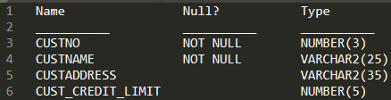
Given: CUSTNO is the PRIMARY KEY.
Required: Determine if any customers’ details have been entered more than once using a different CUSTNO, by listing all duplicate names.
Identify two methods which can be used to get the required result. (Choose two)
- Subquery
- Left outer-join with self-join
- Right outer-join with self-join
- Self-join
- Full outer-join with self-join
Correctas: A,D

